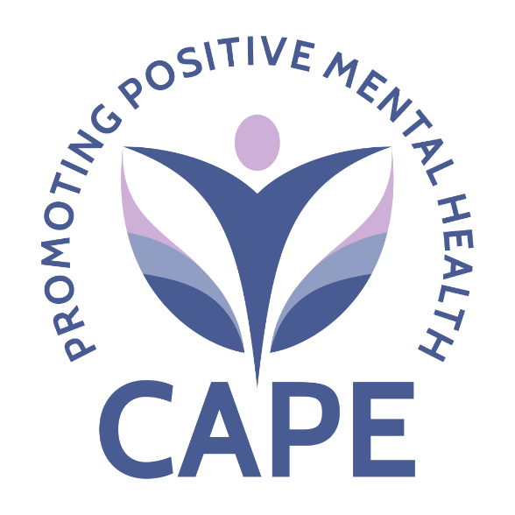

CAPE Anti-Racism Statement
CAPE is committed to being an actively anti-racist organisation. We recognise that racism—individual, institutional and systemic—creates profound injustice and unequal outcomes across mental health, housing, welfare, and wider society. As an organisation that serves people disproportionately harmed by discrimination and inequality, we have a responsibility not only to acknowledge these realities but to challenge them wherever they appear.
We understand that anti-racism requires more than good intentions. It demands continuous action, accountability and a willingness to confront uncomfortable truths. We therefore commit to:

1. Centre Lived Experience and Challenge Inequality
Racism and racial inequity intersect with mental health, poverty and social exclusion. We actively listen to and elevate the voices of people with lived experience of racial injustice, ensuring their knowledge shapes our services, decision-making and advocacy. We recognise that those most affected by racism must be at the heart of solutions.

2. Build an Inclusive, Equitable Organisation
We are committed to creating a workplace and service environment where people of all racial and ethnic backgrounds feel respected, safe and valued. We will review and improve our policies, practices and culture to ensure they promote equity, reduce bias and remove barriers.
This includes ensuring fairness in recruitment, development, pay, access to opportunities and leadership pathways.

3. Confront Our Own Biases and Learn Continuously
We acknowledge that we are not exempt from the biases present in society. We commit to ongoing learning, reflection and training to understand how racism operates—and how we can disrupt it. We welcome challenge from our community, staff and partners as an essential part of growth.

4. Hold Ourselves Accountable
Anti-racism requires transparency and responsibility. CAPE will regularly review our progress, seek feedback, and use data and lived experience to identify where change is needed. We will act on what we learn, recognising that accountability is an active, everyday practice.

5. Advocate for Racial Justice Across Systems
As a provider of mental health support, welfare rights advocacy and community-led systems change work, we see the effects of racial inequality across the systems our clients navigate. We will use our influence and partnerships—including our co-chairing of the Ealing Mental Health and Suicide Prevention Partnership Board—to challenge inequitable policies, amplify marginalised voices and push for fairer, more trauma-informed and culturally competent services.

6. Commit to Action, Not Just Words
This statement is not a one-off declaration but a commitment to ongoing work. We will embed anti-racism into strategy, governance, service design and everyday practice. We recognise that our actions must demonstrate our values.

CAPE stands firmly against racism in all its forms. We are committed to building an organisation—and contributing to a wider society—where racial justice, equity and dignity are a lived reality for everyone.

